**ADD**

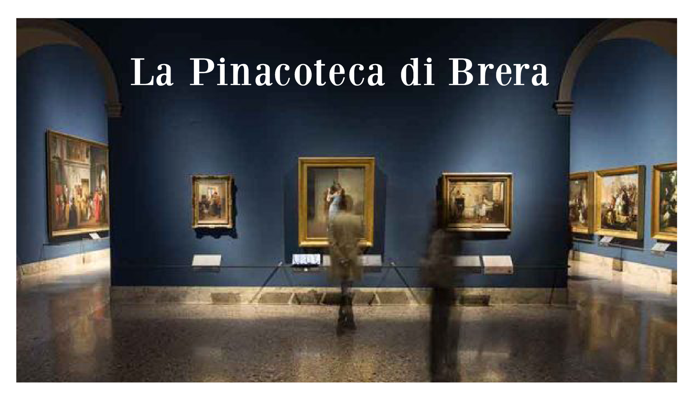

Gamification project

Team 2

**Introduction** **3**

**Style Analysis** **3**

Fonts 3

Color Palette 4

Logos and Icons 5

**Art** **6**

Style 6

Concept Guidelines 6

Character 8

-Sprites 8

**UI** **9**

Screen 9

Icon 9

Button 9

**3D Department** **10**

Blueprint 10

Map 10

Sizing guidelines 10

# Introduction

This project focuses on giving a mix of a functional app and a game experience in which the Player is incentivized to explore both a virtual and the real Pinacoteca to collect and learn about the Paintings.

The Objective is to create an immersive virtual tour of the Pinacoteca in which the Player can interact with some of the Paintings from the real One and can read the story behind the Painting, the Painter or other curiosity about it, then the Player is incentivised to explore the real Pinacoteca for more information.

# Style Analysis

Here are references taken for the website of the Pinacoteca as to how the app will have to look in regards to fonts, color palette and main logos and icons

## Fonts

We identified two principal fonts present in the website and we researched the ones most similar to them.

To **download**, **click on font the image** and a link will appear

The **Bodoni XT** font is to be used for all the **Main title texts**.

[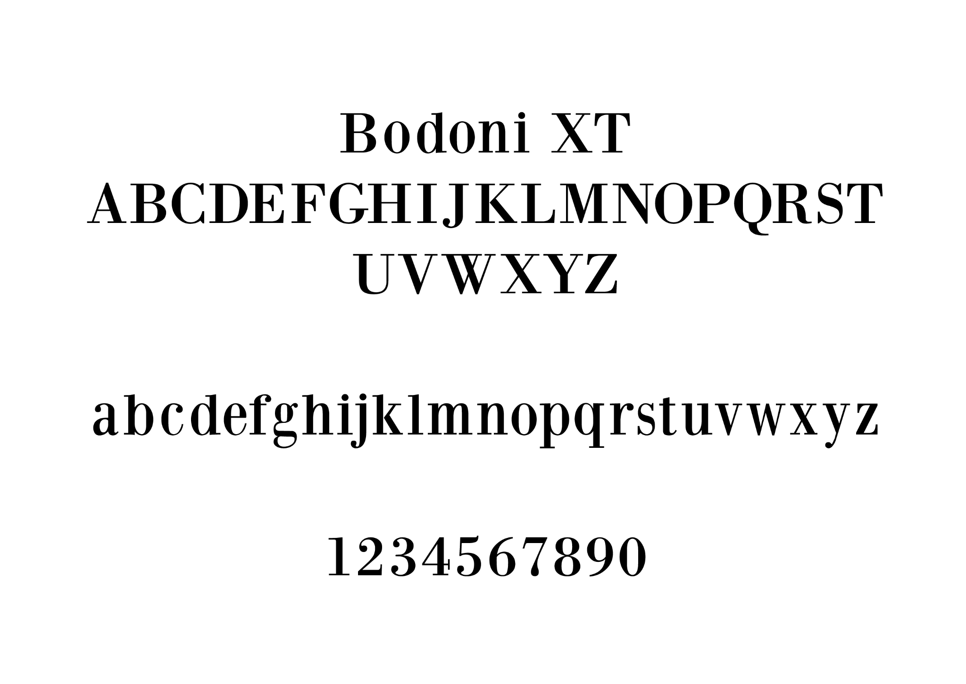](https://www.dafont.com/it/bodoni-xt.font)

While the **Taylor Serif** is to be used on all **secondary texts**.

[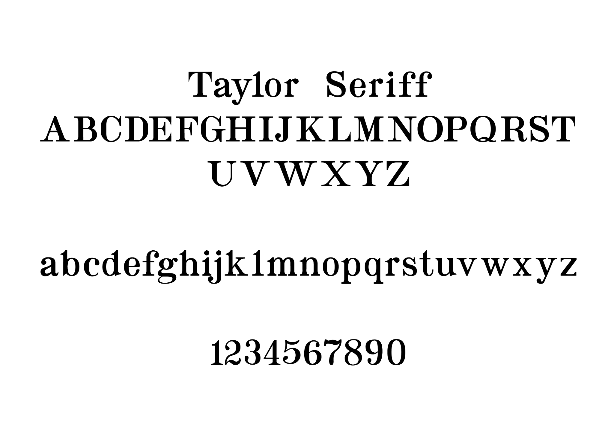](https://www.dafont.com/it/taylor-serif.font)

## Color Palette

These are all the colors present in the Brera website, in order to keep the app as **cohesive** as possible with it, **only use these colors** when creating **icons and menus**.

RGB codes present on the image.

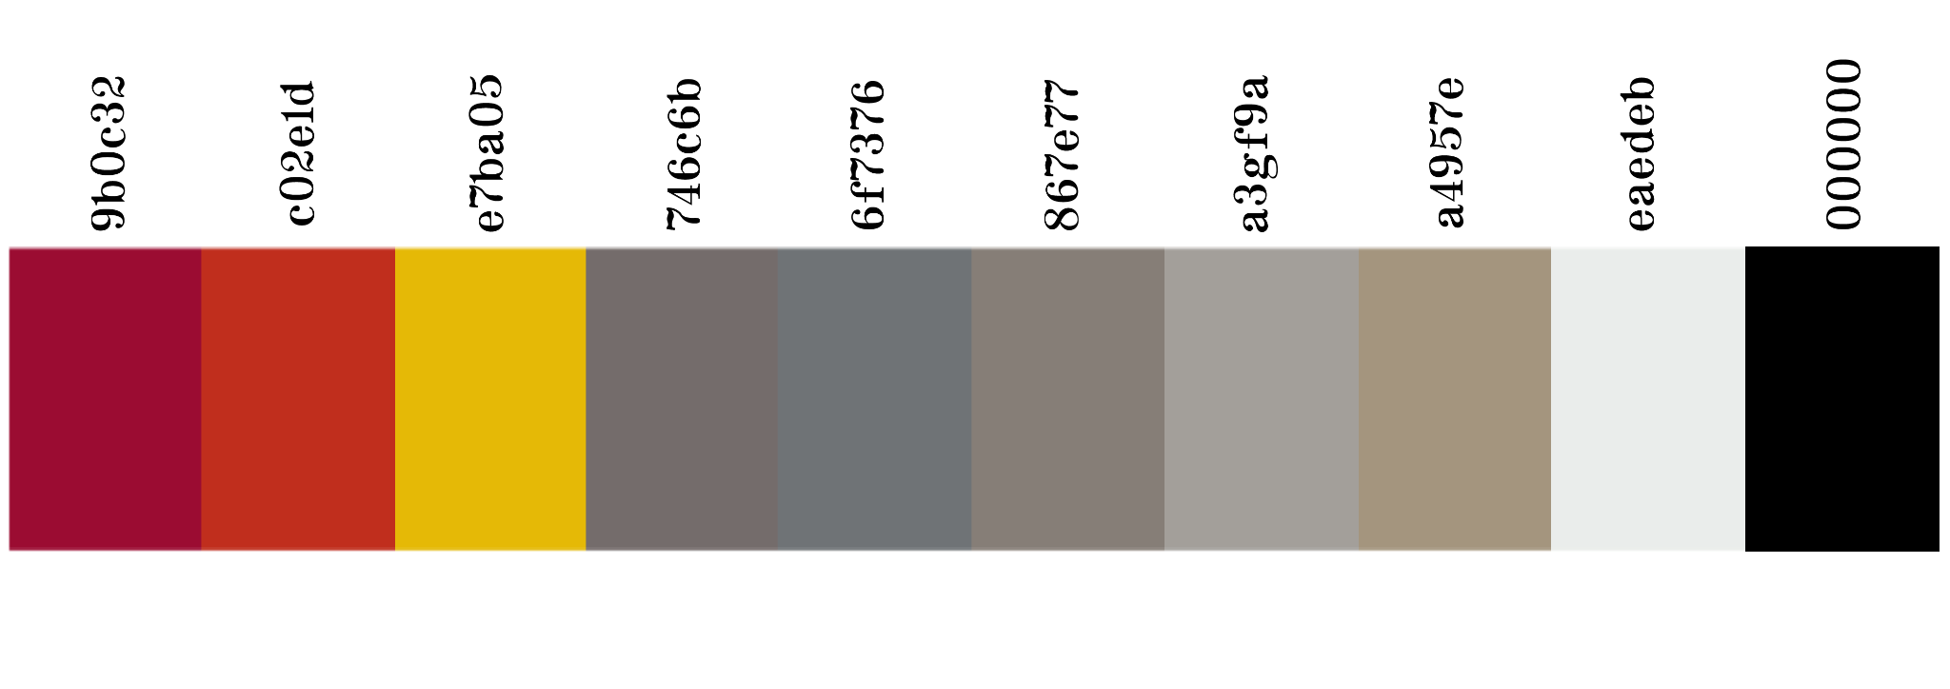

## Logos and Icons

Here is the official Logo of the Pinacoteca along with a couple of other logos present on the website and some other Icons that have been identified.

Transparent png image of the main logo can be found at this [**link**](https://drive.google.com/drive/folders/1F3qwZDVRaDvGPxZ92ffzlMKSFnbpwnv2?usp=share_link) with all the other icons

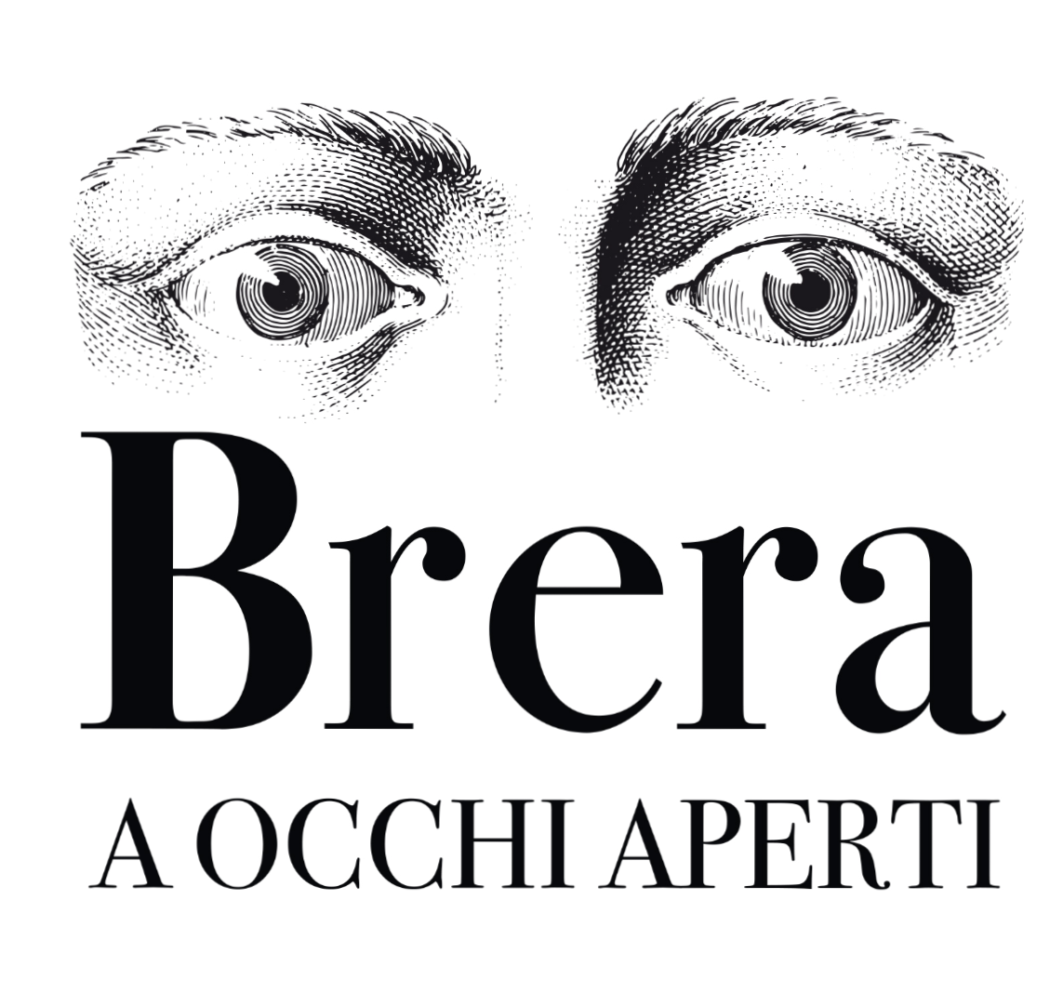

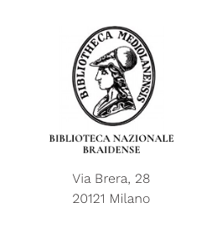

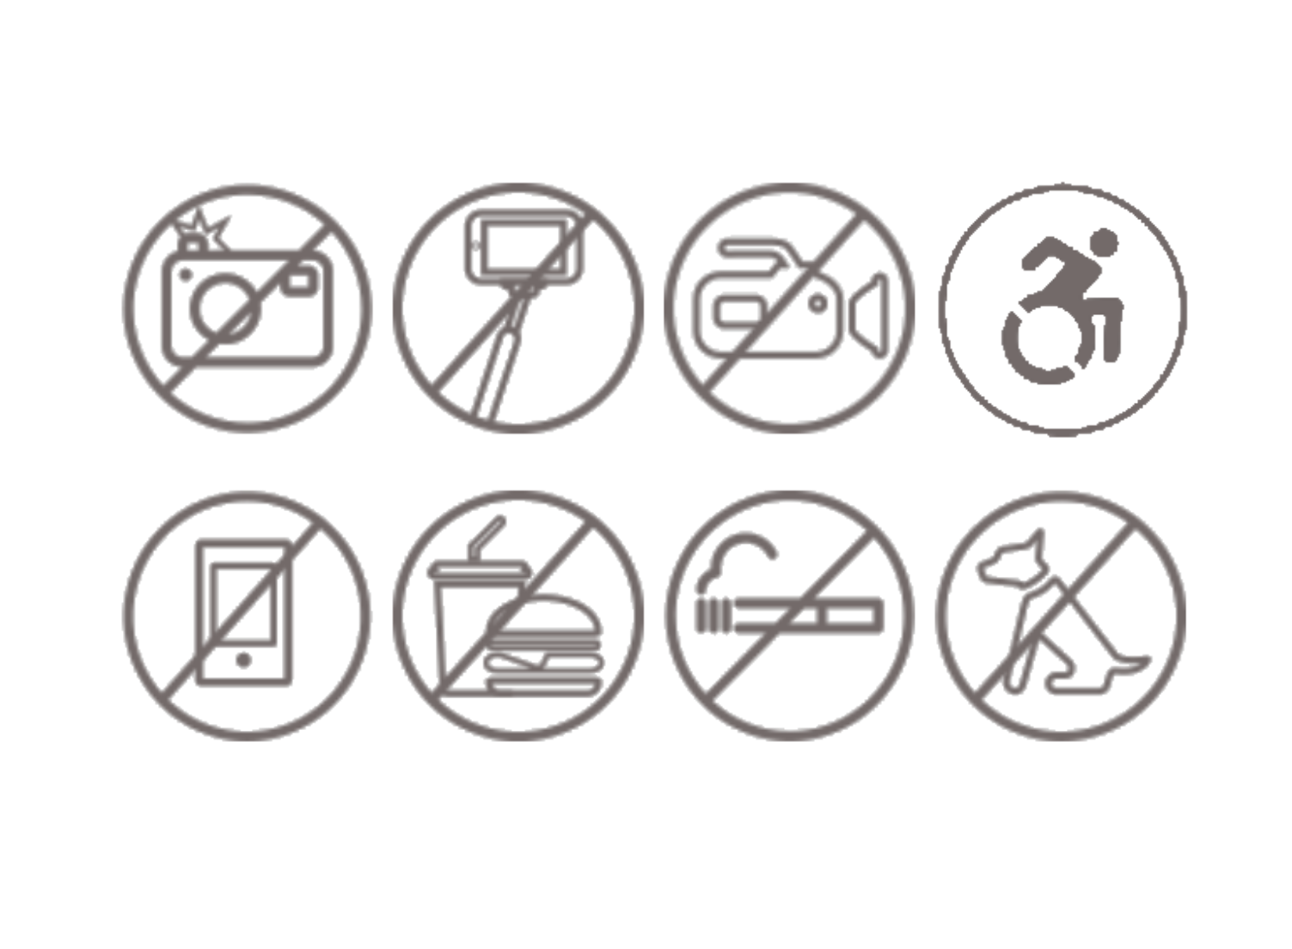 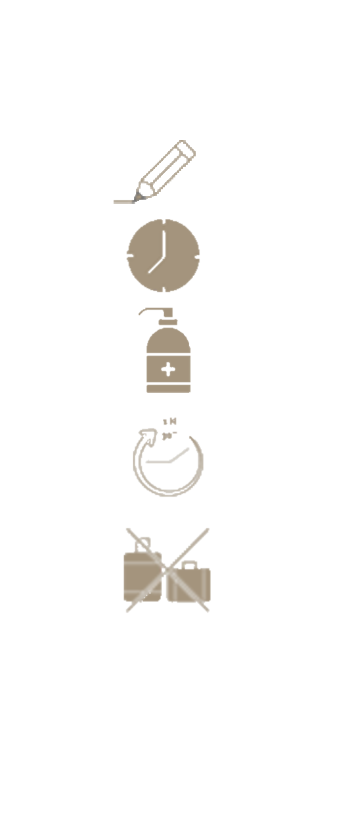

# Art

## Style

Artistically speaking we are aiming for a **realistic graphic**, to reproduce the gallery with accuracy.

Apart from the Guide Character there will be no artistic interpretation and all **assets** will have to be **as realistic as possible** so that the 3D department will have an easy job recreating them.

***References*** and ***Moodboards*** can be found in the[***Drive***](https://drive.google.com/drive/u/0/folders/1pzQNtKRdE4Fz2p2sdtNY4eSA8gmk3oLy)

## Concept Guidelines

When creating the [**assets**](https://docs.google.com/spreadsheets/d/1pQvJCAMWpOAGGre3n0TuICfybd8VkHcDGAONfdX3GEw/edit#gid=0) follow these guidelines so that all will look cohesive and made by a team plus being more easy to read for the 3D team.

**Follow the mock up** **position** and **overall dimension**.

*Use the Bodoni XT font*

*C3D_Example_01a* ***must*** *contain:*

- *Code Asset* and *Artist Name*

- 3 views in *lineart*

- *measurement* directly on the drawing

*C3D_ExampleColor_01a* ***must*** *contain:*

- *Code Asset* (same as the normal C3D but with "Color" after the Name) and *Artist Name*

- 1 view (front) in *lineart* and *colored*

Each Task requires:

- Upload (to Drive, Github) both Concept art

- Upload (to Drive, Github) the 3 view in lineart with transparent background (cut it as small as possible),

each should be called C3D_ExampleFront/Side/Top_01a

- Upload (to Drive, Github) the view colored with transparent background (cut it as small as possible) should be called C3D_ExampleColored_01a

If help is needed or something is not clear feel free to ask to the Art Directors or Designer

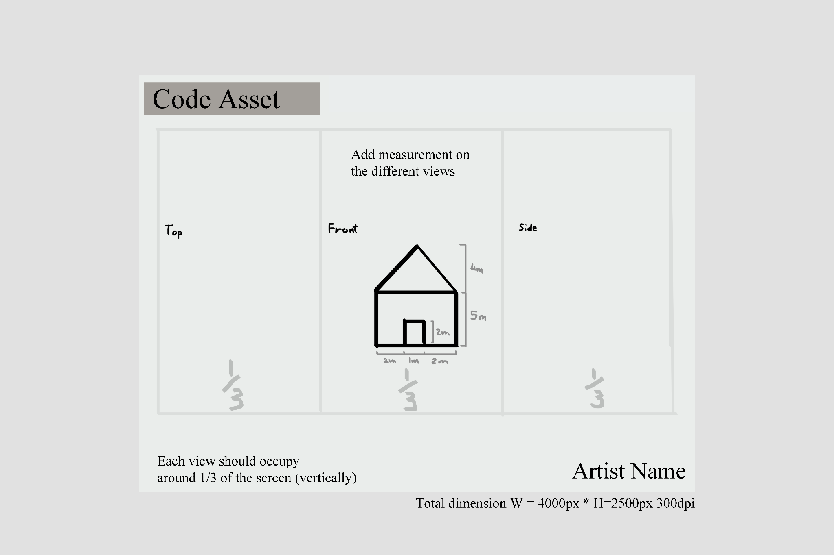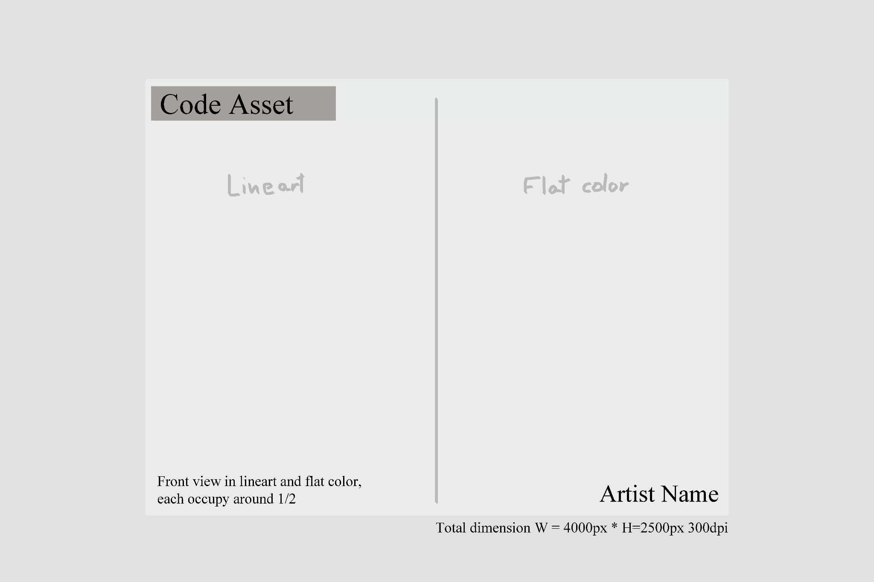

## 

## Character

This **character** is the **only stylized** element inside the game, it’ll work as a guide to the player/user narrating facts about the paintings, artists and general informations (?)

The character will be Artist **Francesco Hayez** whom also was for a time, president at the Accademia of Brera, main references are Hand puppets and **flat paper puppets** with **limited movemen**t in only the **mouth** and **arms**.

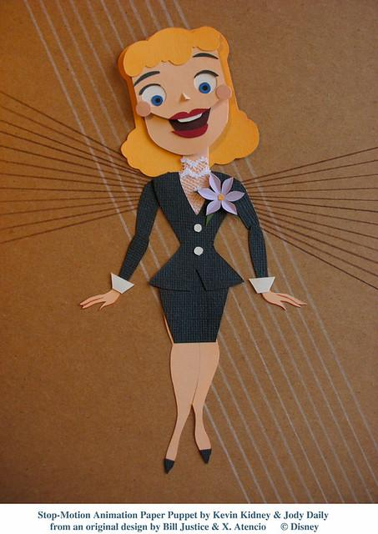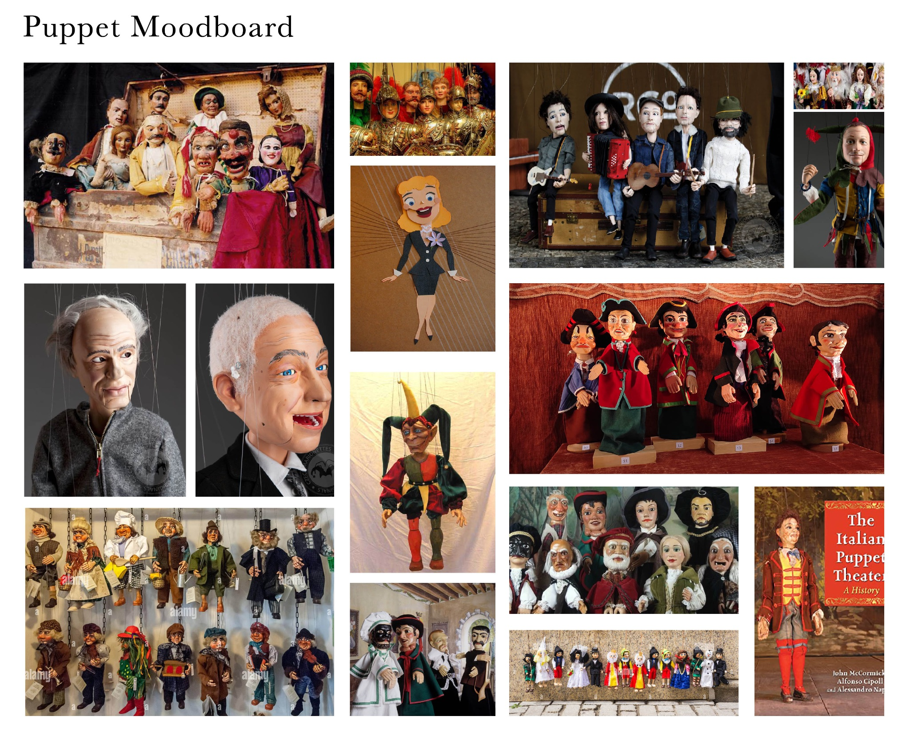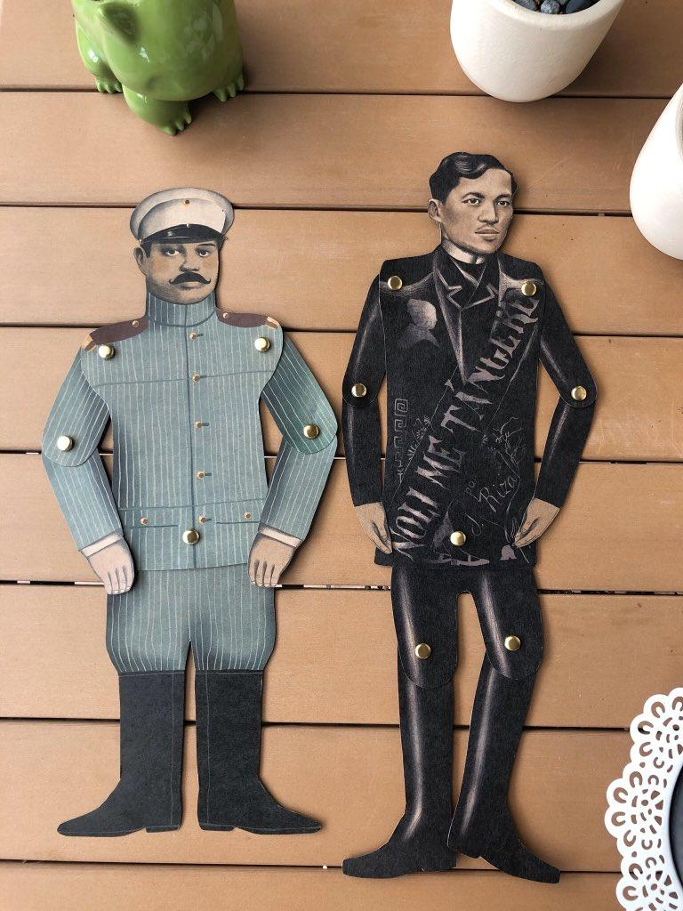

## -Sprites

To simplify the **animation** process draw the different parts that are moving

**- mouth, arms -** in the different positions they can have.

The **mouth** will only move **up and down**

The **arms** will move **up and down to the side**

Here is an example of the canvas setting

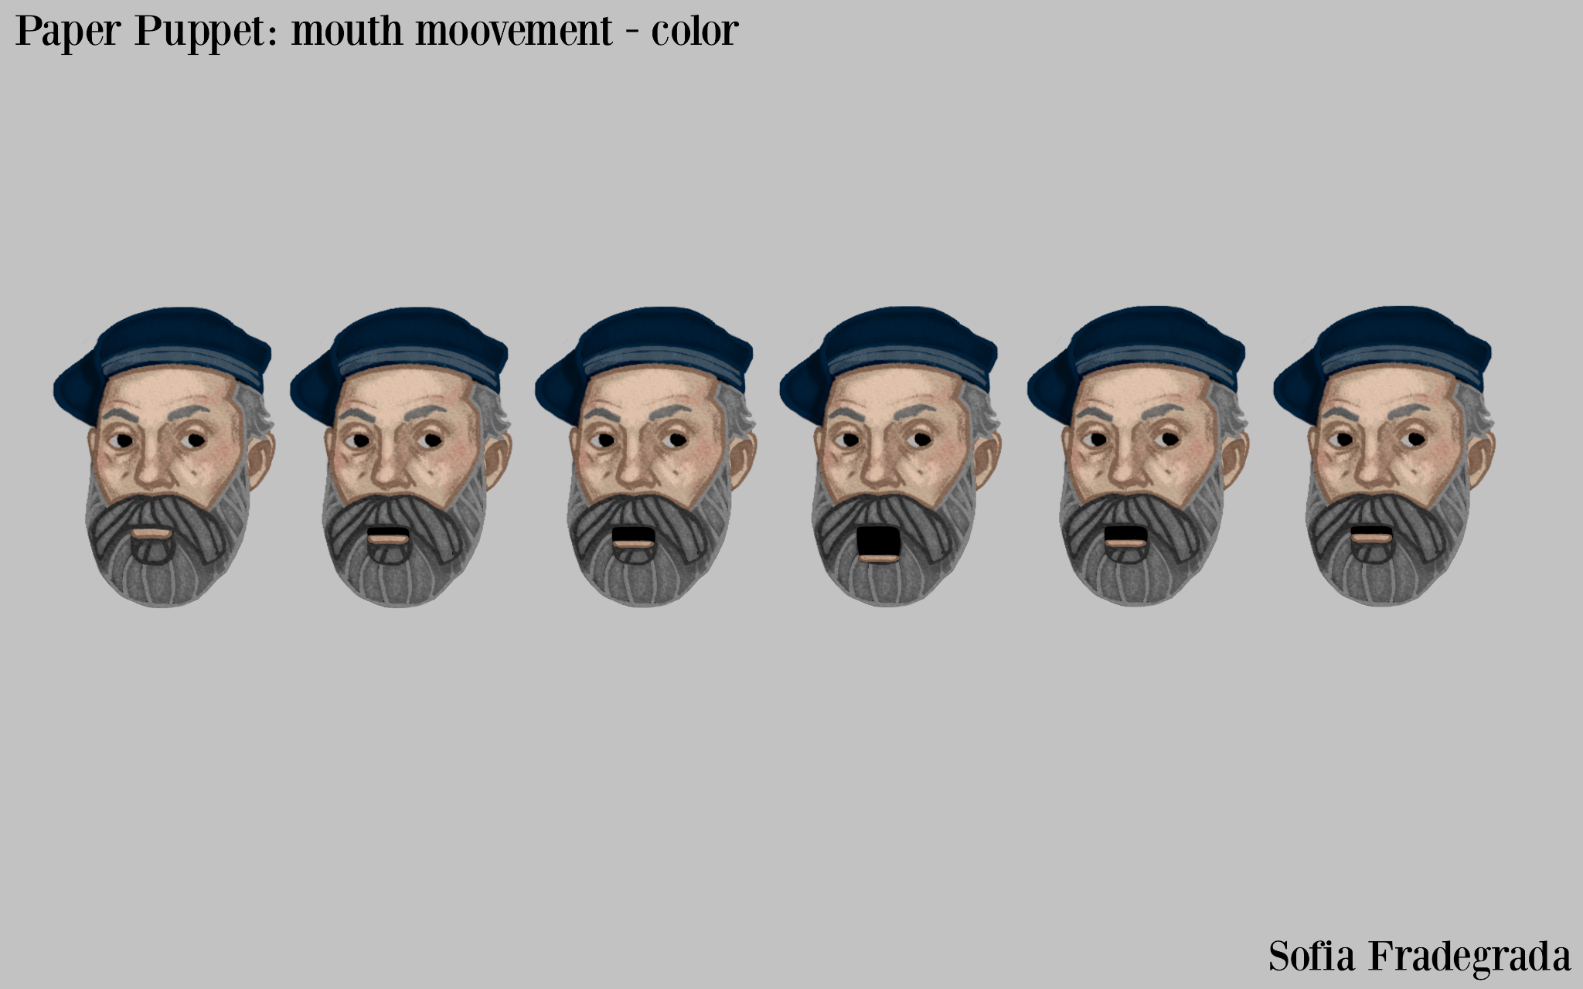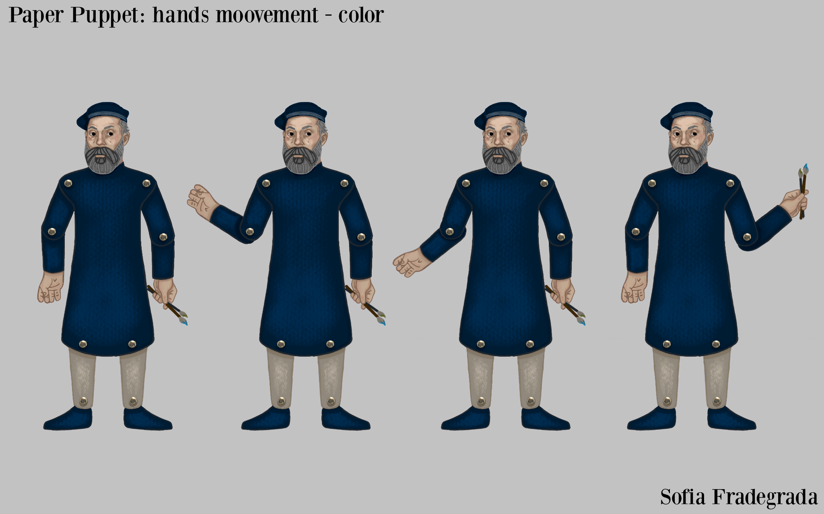

# UI

[***Link GDD***](https://docs.google.com/document/d/1Gm2cMrUdJE2yhtVlOkDs4UPef9w6iDamsHUTxg_RhfU/edit#heading=h.ykftvsx3qoni)

The UI is a main aspect of the game, it should function as a hub for information about the museum and also a companion app to augment the experience during the museum visit.

A small change is made to the style, going for a more modern look, in line with other museum apps, to appeal more to those downloading this companion app.

References:

Because it's also a companion app, some functions are also integrated, like the map, the chance to buy tickets and extensive info about the operas, with the objective to create a more interactive and personal experience, appealing to the experience seeker.

## Screen

The Screens are clean and not overly detailed, keeping a slick design and no fancy decoration.

Some pop-up screens also have sliding animations.

## Icon

The Icons follow the same principle as the other elements.

## Button

The buttons follow the same principle as the other elements and add a shrink and enlarge animation when clicked.

# 3D Department

During the Project the 3D Department is tasked to:  
- model the blueprint (concept), UV and Material of props given by the 2D Department.

- model the blueprint, UV and Material of map given by the Design Department.

- the lighting of the map.

- the Post Processing effects.

## Blueprint

The blueprint of the props should follow the given size and color in the blueprint.

The props have given measurement.

## Map

The map is divided into 2 macro elements: corridor and big room.

The big room is modular, divided in 3 elements (floor, wall, ceiling).

## Sizing guidelines

The overall size is based on the real museum giving a human scale to every prop and the map.

# [Naming Convention](https://docs.google.com/spreadsheets/d/1r9fnP8SHlay7EBbjYJKvhKce5EGSD_zMLvSzTW6Ykrg/edit?usp=share_link)

## 

Follow the link above to see all the needed instructions on how to name your files